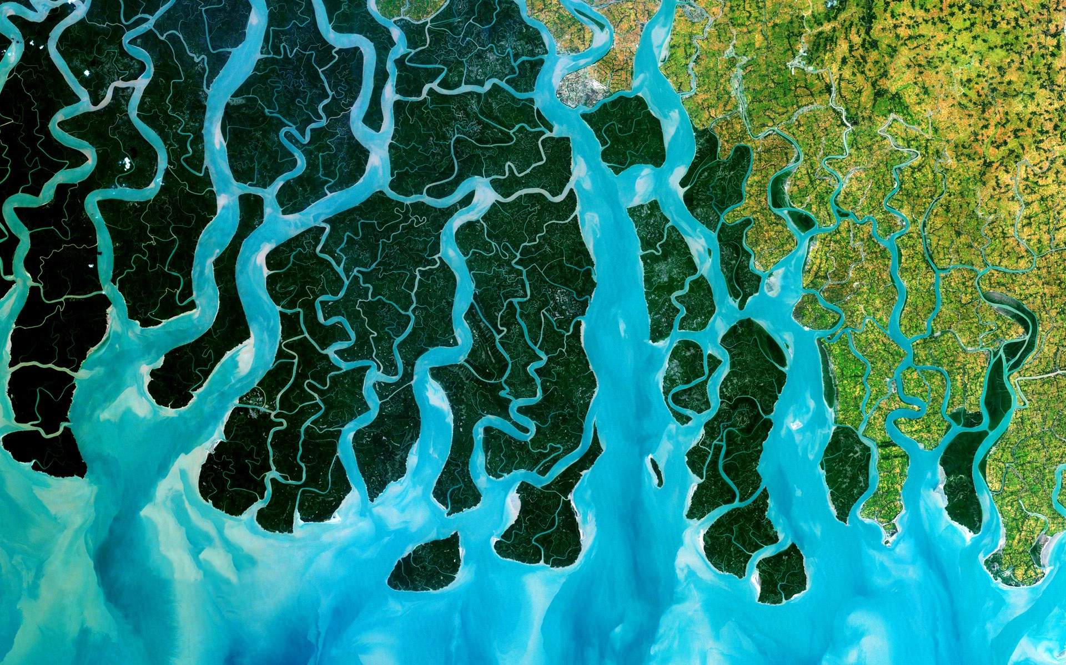

TERM 1 UNIT OUTLINE – GEOGRAPHY – 2023 DRAFT

YEAR 7 HASS

The concepts of [place](https://k10outline.scsa.wa.edu.au/home/p-10-curriculum/curriculum-browser/syllabus/humanities-overview/glossary/place), [space](https://k10outline.scsa.wa.edu.au/home/p-10-curriculum/curriculum-browser/syllabus/humanities-overview/glossary/space), environment, [interconnection](https://k10outline.scsa.wa.edu.au/home/p-10-curriculum/curriculum-browser/syllabus/humanities-overview/glossary/interconnection), sustainability and [change](https://k10outline.scsa.wa.edu.au/home/p-10-curriculum/curriculum-browser/syllabus/humanities-overview/glossary/change) continue to be developed as a way of thinking and provide students with the opportunity to inquire into the nature of water as a natural resource. The concept of [place](https://k10outline.scsa.wa.edu.au/home/p-10-curriculum/curriculum-browser/syllabus/humanities-overview/glossary/place) is expanded through students' investigation of the [liveability](https://k10outline.scsa.wa.edu.au/home/p-10-curriculum/curriculum-browser/syllabus/humanities-overview/glossary/liveability) of their own [place](https://k10outline.scsa.wa.edu.au/home/p-10-curriculum/curriculum-browser/syllabus/humanities-overview/glossary/place). They apply this understanding to a wide range of places and environments at the full range of scales, from [local](https://k10outline.scsa.wa.edu.au/home/p-10-curriculum/curriculum-browser/syllabus/humanities-overview/glossary/local) to global, and in a range of locations**.**

|  |  |  |  |  |  |
| --- | --- | --- | --- | --- | --- |
| **Year 7 - Geography Unit Outline – Term 3, Semester Two 2023** | | | | | |
| **Water and the World** | | | | | |
| **Week** | **Notes** | **Lesson 1** | **Lesson 2** | **Lesson 3** | **Lesson 4** |
| *The classification of*[*environmental resources*](https://k10outline.scsa.wa.edu.au/home/p-10-curriculum/curriculum-browser/syllabus/humanities-overview/glossary/environmental-resources) *(renewable and non-renewable) (ACHGK037)* | | | | | |
| 1 |  | Lesson for setting expectations for classroom/introduction to HASS/icebreakers etc. Teacher choice.  **Weekly Learning Intentions:**  *Week 1 Learning Intentions:*  *1. Define the study of Geography.*  *2. Understand the key concepts of Geography.*  *3. Describe some skills used in the study of Geography.* | **Learning Intention (LI):** Introduce course – what is to be studied in Geography this term – Water and the World, Place and Liveability.  **Success Criteria (SC):** Able to explain why the study of geography is important with examples. | **Learning Intention (LI):** Introduce Geography and SPICESS Key Concepts (KC)  **Success Criteria (SC):** Can recall/define the definition of Geography. Able to list and provide examples of SPICESS. | **Learning Intention (LI):** Introduce Geography and SPICESS Key Concepts (KC)  **Success Criteria (SC):** Can recall/define the definition of Geography. Able to list and provide examples of SPICESS. |
|  | **Suggested Lesson Activities/Resources:**  Introduction to Geography and SPICESS PowerPoint and SPICESS Student Table worksheet (Learning Area Drive)  World Map Labelling Activity or BOLTSS Activity | **Suggested Lesson Activities:**  Intro. Geography and SPICESS PowerPoint (HASS Drive)  <https://www.youtube.com/watch?v=5FVgg_u3auA>  Concept map of key geographical concepts with definitions and examples  GLOSSARY – Definition of the study of Geography and they 2 branches of geography (human and physical)  **Suggested Resources:**  SCSA Concepts Diagram  SPICESS concept map Handout | Same as previous lesson.  Atlas Race as Do Now. |
| **Week** | **Notes** | **Lesson 1** | **Lesson 2** | **Lesson 3** | **Lesson 4** |
| *The quantity and variability of Australia's water resources compared with those in other continents (ACHGK039)* | | | | | |
| 2 |  | **LI:** Introduce *Water in the World* topic by starting with the classification of environmental resources.  **SC:** Students can define what a natural resource is.  Students to understand the difference between renewable and non-renewable resources. | LI: Understand the importance of water as a natural resource.  **SC:** Students can list ways that waters is used by humans | * **LI:** Understand process of the Water Cycle and it’s key elements (PERTIC)   **SC:** Able to label a diagram of the water cycle and list the processes involved (PERTIC) | LI: Use the PQE skill to describe the world’s freshwater resources  SC: Is able to list what PQE stands for  Can describe where the majority of the world’s fresh water is located |
| **Suggested Lesson Activities:**   * Define ‘*environmental resources’*. * Define ‘*renewable, non-renewable resources and continuous resources’.*   Construct a table on file paper using a red pen or pencil and a ruler, list examples for each type of resource.   |  |  |  | | --- | --- | --- | | Renewable  Resources | Non-renewable Resources | Continuous  Resources | |  |  |  |   Page 72-73 of Pearson HASS WA  P.42-43 Oxford WA  Resources Worksheet (Learning Area Drive) | **Suggested Lesson Activities:**   * Revise environmental resources and the three types * Thewaterweeat.com * Students come up with a water log * Investigate Indigenous water use (Oxford p. 78-79) * Brainstorm water use as a class | **Suggested Lesson Activities:**   * The Water Cycle – define what the water cycle is and look at the key elements of the water cycle. * Look at each process of the water cycle, such as PERTIC. (**Precipitation, Evaporation, Run-off, Transpiration, Infiltration, Condensation)** * Discuss and brainstorm the human impacts and how humans interact with the water cycle. * Link the water cycle to the big idea of quantity and variability of water resources. * Look at a diagram of the Water Cycle | **Suggested Lesson Activities:**   * P.48-49 Oxford Textbook Activity * P. 70-71 Oxford textbook. |

|  |  |  |  |  |  |  |
| --- | --- | --- | --- | --- | --- | --- |
| **Week** | **Notes** | **Lesson 1** | **Lesson 2** | | **Lesson 3** | **Lesson 4** |
| *The quantity and variability of Australia's water resources compared with those in other continents (ACHGK039)* | | | | | | |
| **3** |  | **Catch up lesson if needed!**  **Revise all previous content including water cycle, SPICESS, resources, PQE.** | **LI:** Understand ways that geographical data can be presented (table and graph) using climate graphs.  SC: Student is able to analyse and create a climate graph. | * **LI:** Understand the variability of water resources in Australia and other continents around the world.   **SC:** Able to describe the quantity and variability of water. | | **LI:** Understand water scarcity and the different types of water scarcity.  **SC:** Define and provide examples of Water Scarcity around the world and in Australia. |
| -Kahoot  -Revision quiz  -Mindmapping  -Give one, get one  -Audit of student notes | **Suggested Lesson Activities:**   * Oxford skills book p.8-9 * Oxford skills book p. 18-19 * Oxford textbook p.66-67 | **Suggested Lesson Activities:**   * Recap and review the definition of ‘water’. * Define the terms *quantity and variability, plus define and understand the names of the Worlds Continents. Mapping Skills: Incorporate direction. E.g. the direction of Australia from Africa*   Look at the concept of *groundwater.* Discuss the advantages and disadvantages of groundwater. Why is groundwater a renewable resource?  Define the term *aquifer. Discuss where the world’s aquifers are located.*  **Resources:**  Water Variability PowerPoint  Pearson HASS WA 7. (Pages 78-79) | | **Suggested Lesson Activities:**   * Water Scarcity – look at types of water scarcity. Page 90-91 Pearson HASS WA 7. * Case Study – Water scarcity in Africa. * Define the following terms – scarcity, desalination, consumption, water recycling. * -Reasons for water scarcity in areas around the world * -Water scarcity in Africa (Page 126-127) * -Water scarce in west-Asia and North Africa (Page 128-129) * -Water crises in West Asia (Page 130-131) * Complete activity 5 a b c page 91 of Pearson HASS WA 7. * Brainstorm what we use water for. Complete a Think-Pair-Share. * Look at types of water – Blue Water, Green Water and Grey Water. * Complete activity 5 page 93. |